**Weather Data Collection at SCBI-Front Royal-Posey Hollow**

PI: Kristina Teixeira

Prepared by: Ian McGregor

Last updated: June 2019 **Method:** LoggerLink App and wifi

BEFORE you go to the field, make sure

* tablet or phone is fully charged
* it has at least 100 MB storage space
* it has the “LoggerLink” app installed

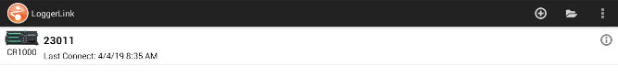

Collecting MetData:

1. To connect, select the datalogger from the main screen, and

it will automatically connect to the datalogger.

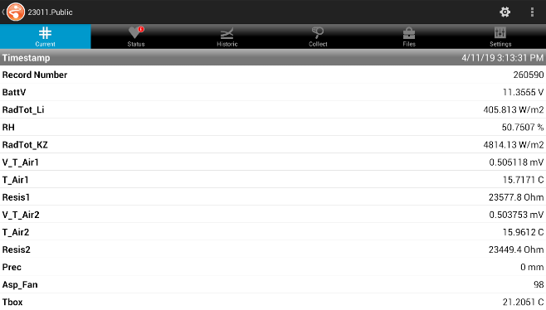

1. To collect data, navigate to “Collect”. You’ll be given the

options

* 1. “All” = all data on the sensor
  2. “New” = data since last collect
  3. “Most recent” = data back to a specified time

(e.g. last 100 hours)

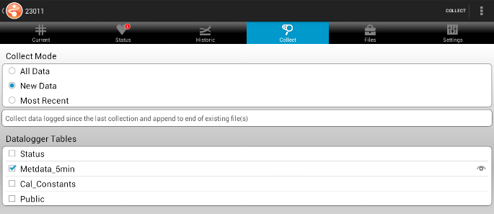

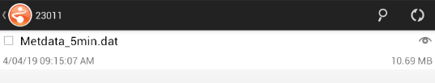

1. Choose one of the options, then press “Collect.”
   1. For a month’s worth of data (~10,500 entries), it takes

about 10 minutes to collect.

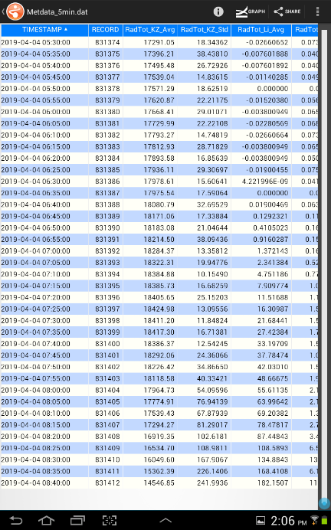

1. When it’s done, you’ll see a page with the .dat file called

“Metdata_5min.dat”. Click on the eye symbol, and it will say

“Indexing file” (takes a minute or two) before you can preview the

data you just collected.

* 1. Verify the data is up to date and what you want.

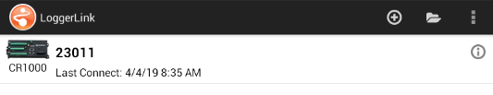In the lab, on tablet:

1. Open the LoggerLink app again, and select the open

folder icon in the top right.

1. 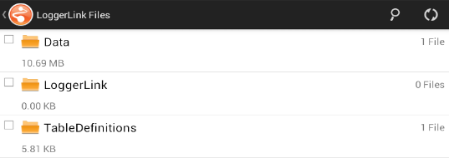Select “Data”, then select “23011” (the datalogger number),

then select the eye icon (or the 3 vertical dots), then “View file.”

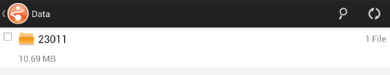



1. 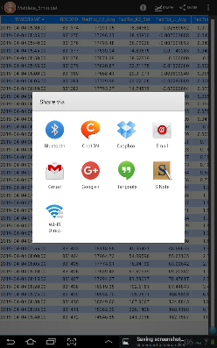Make sure you are fully connected to wifi in lab.
   1. Will probably have to reconnect and authenticate.
2. Navigate to “Share”, and select Gmail. Send email to yourself.
   1. This can take a while depending on wifi strength.
   2. You can verify progress in the Gmail app from the home screen.

In the lab, on computer:

1. Save the raw file to T:\SIGEO\Met tower\Meteo DATA\TXT_Files\ and change

file name to include date of collection (e.g. Weather-CR1000_Metdata_5min_08232018).

1. Change the file extension to .txt.
2. Paste new data in the .txt file ‘SCB_Metdata_5min_YEAR’.
   1. Select data quickly using Ctrl+Shift+End.
3. Also update new data in the .csv file: ‘SCB_Metdata_5min_YEAR’.
   1. In Excel 2016 and newer, open the .txt file you updated in Step 3.
   2. Click “Save As”, change “Save as type” to “All Files” and select the current .csv. Click Yes to replace.
   3. For older versions of Excel see 3rd sheet of this document.

We use the SI network as backup repository BUT next step is more important!

1. Ask Krista to send you an invitation to access the ‘Climate Repository’ in GitHub.
2. Steps on Github:
   1. Navigate to your local GitHub repositories. Move the updated .csv to

- forestgeo\Climate\Met_Station_Data\SCBI\ForestGEO_met_station-SCBI

* 1. Open GitHub desktop. You will see the modified file in your history
  2. Make a comment in Github (i.e. in Summary: “Updated records for 2018”, in Description: add any relevant comment or none)
  3. Commit to master.
  4. Push!

1. Once the data has been uploaded to the T drive AND pushed to GitHub,

go ahead and delete from the tablet in order to keep memory space open.

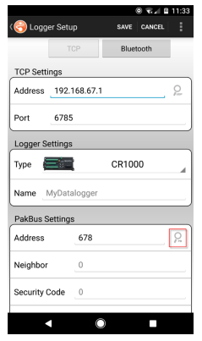In the field, setting up for the first time:

1. Open upper metal box on tower.
2. Connect your phone/tablet to the NL241 wifi and open LoggerLink app.
3. In the app, press the + key to add a datalogger.
4. Make sure **TCP** selected, then tap the Search button to discover any

devices on the wifi network.

1. Select the NL241
2. Fields will be filled automatically.
   1. **Port** is 6785
   2. The default of the PakBus Address is 678, but we found that

switching this to “1” allowed it to connect.

* 1. Instead, 678 should be in the **Neighbor** field.

1. Press **Save**, and you’ll be taken back to the main screen.

BEFORE you go to the field, make sure

* tablet or phone is fully charged
* it has at least 500 MB storage space <- possibly more memory needed for first time
* it has the “LoggerLink” app installed

How to import data with Excel older than 365

1. Also update new data in the .csv file: SCB_Metdata_5min_YEAR.
   1. In Excel, select the first empty cell in column A. Go to “Data”, then “Get External Data” and “From text.”
   2. Select the .txt file you just updated in Step 3. Start import at the same row number as the first empty row in the csv file (where you selected). This ensures it only imports what you need starting at that empty cell.